* 1. **Architectural Design**
     1. Information system architecture

**INPUT**

**(Data)**

* Customer Information
* Order Information
* Customized Design
* Payment Information

**PROCESS**

**(Operation)**

* Monitor Inventory
* Manage Orders
* Monitor Production
* Monitor Delivery
* Process Payment
* Manage Collections
* Generate Reports

**OUTPUT**

**(Reports/Output)**

* Official Receipt
* Billing Receipt
* Delivery Receipt
* Job Order Form
* Order Report
* Sales Report
* Inventory Report
* Production Report

DATABASE

***Figure 3.5 Information System Architecture***

* + 1. **Web Architecture**

BROWSER (Google Chrome, Mozilla Firefox, Microsoft Edge, Mobile Browser)

OWNER, MANAGER, CUSTOMER

ORDER MANAGEMENT, BILLING AND COLLECTIONS, PRODUCTION TRACKING

DATABASE

***Figure 3.6 Web Architecture***

* + 1. 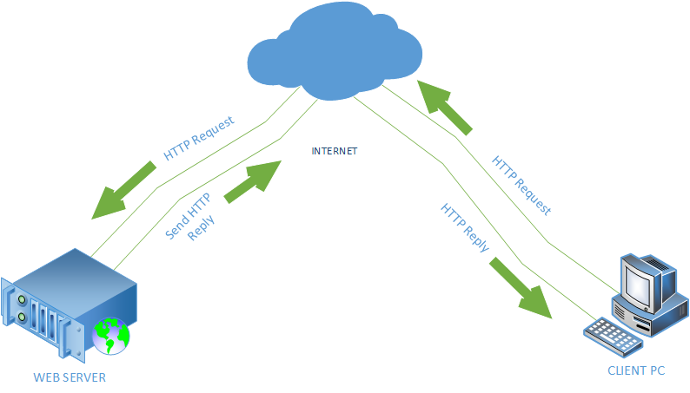**Client/Server Architecture**
    2. **Network Architecture**

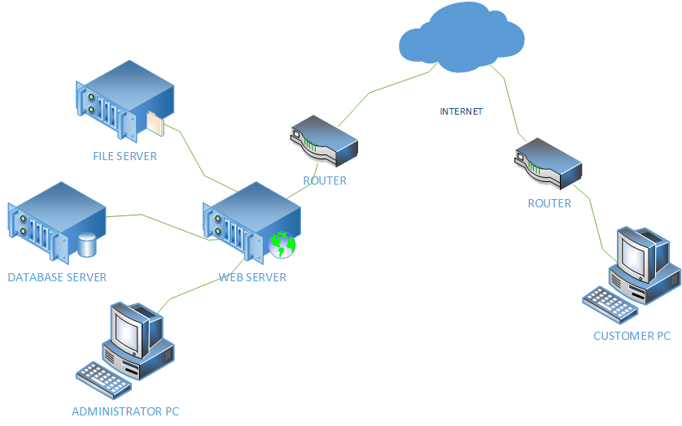

**CHAPTER 4**

**IMPLEMENTATION PLAN**

**4.1 TESTING PLAN**

**4.1.1 Test Design Process**

The developed system should satisfy and ensure that it meets all the requiremens before testing. The first testing of the developed system should be conducted by the proponents, which leads to the formulation of the test case or scripts. After the evaluation of the test case, if the final result is passed, the system should continue for testin and evaluating by the client before the developed system is released for implementation.

**4.1.2 Test Execution Process**

The developed system must be ready for assessment and testing. The process should include test case or script which will be use to assess if the developed system Passed or Fail. The developed system should undergo full assessment or subsequent testing, because if one component is missed for testing, it can affect or arise a conflict in the business process as well as the systems’ process. The process shall continue and will last until it is completed and all the test case are marked as Passed. Afer the test executed, the developed system shall proceed to client’s evaluation. Next phase, the system should be ready for connection testing between the servers and the system which should be connected by the proponents.

**4.2. REQUIREMENTS PLAN**

**4.2.1 Hardware Requirements**

**4.2.1.1 Server**

|  |  |
| --- | --- |
| **Hardware Component** | **Specification** |
| Processor | 2 GHz, Intel Core i7 |
| Installed Memory (RAM) | 8.00GB or higher |
| Network | 5Mbps |
| Hard Disk Drive | 1TB or higher |

* + - 1. **Workstation**

|  |  |
| --- | --- |
| **COMPONENT** | **SPECIFICATION** |
| Operating System | Windows 7 or higher, MAC OS |
| DBMS | MySQL |
| Web Browser | Google Chrome, Mozilla Fireworks, Microsoft Edge, Mobile Browser |

**4.2.2 Software Requirements**

|  |  |
| --- | --- |
| **COMPONENT** | **SPECIFICATION** |
| Language | PHP, HTML, CSS |
| Browser | Google Chrome, Mozilla Fireworks, Microsoft Edge, Mobile Browser |
| Web Browser | Google Chrome, Mozilla Fireworks, Microsoft Edge, Mobile Browser |

* + - 1. **Operating Systems**

|  |  |
| --- | --- |
| **COMPONENT** | **SPECIFICATION** |
| System Name | Furniture Shop Management System |
| Operating System | Windows 7 or higher, MAC OS |

* + - 1. **DBMS**

|  |  |
| --- | --- |
| **COMPONENT** | **SPECIFICATION** |
| Database | MySQL |

* + 1. **Peopleware (End Users, Systems Administration, Etc)**

|  |  |
| --- | --- |
| **ACTOR** | **RESPONSIBILITIES** |
| Furniture Shop Owner/Manager | Administrator of the Furniture Shop Management System. Head of the Furniture Shop. Manages transactions of the system. |
| Customer | Orders a furniture, can be from the brochures or sent customize design. Monitors production and delivery of his/her purchased order. |

* 1. **Quality Plan**

The proponents attests that the system is efficient and followed the requirements of the client. It is aligned with the performance, accuracy, reliability and acceptability that will satisfy the requisites of the system. I also assure the following:

* User friendliness of the system.
* Faster processing of business transactions.
* Valid and reliable outputs/documents.
  1. **Security Plan**

|  |  |
| --- | --- |
| **SECURITY POLICIES** | **SECURITY FEATURES** |
| * User Policies | Users allowed to access the system will only be the owner/manager and anyone logged-in user from the website. |
| * Password Policies | Restriction of access of records for files containing confidential informations. The system secures restriction of access from authenticated users only. |
| * Internet Policies | The website has a feature of CAPTCHA that secures informations from possible attacker. |

* 1. **System Maintenance and Support Plan**

**4.5.1 Preventive Measure Plan**

|  |  |
| --- | --- |
| **RISK/THREAT** | **PREVENTIVE MEASURES** |
| Hacking | * Installed anti-virus, anti-malware and a firewall software. |
| Computer Viruses | * Keep anti-virus software updated. * Do not click suspicious ads or emails. |
| Electricity Interruption | * Back up files regularly, to multiple locations. * Sync data in a safe and trusted server. |
| Hard Drive Failure | * Clean and remove dusts from the PC. * Avoid getting your PC intensely hot. |

* + 1. **Corrective Measure Plan**

|  |  |
| --- | --- |
| **RISK/THREAT** | **CORRECTIVE MEASURES** |
| Hacking | * Secure files with passwords not related to your personal information. |
| Computer Viruses | * Scan for viruses with the malware software installed on your PC. |
| Electricity Interruption | * Retrieve files from the synced data from the trusted host server. |
| Hard Drive Failure | * Contact a person regarding the failure of the hard drive. |

**4.5.3. Backup and Recovery Plan**

To secure the files and functionality of the system, it must have a backup plan. The proponents think of the following as backup and recovery plan:

* Virus/Malware

In case of an attack from the viruses, the system must have installed anti-virus software that will avoid the virus to spread.

* File Corruption

To secure files from the system, the proponents determine to have File Server Backup Software installed. To keep files from the transactions made in the system.

**CHAPTER 5**

**RECOMMENDATION**

Upon determining and evaluating every problems encountered by the business, the proponents affirm that the Furniture Shop Management System will be effective in helping the furniture shop from its tedious business process of managing orders and monitoring its production and delivery operation.

The system will be able to lessen the excessive use of papers, and the voluminous brochures. Charts of fabric are organizely stored in the system, wherein the customers can choose from the list of it. It also uses the proper forms needed for every transaction made that will decrease the possible rate of losing a data.

With the Furniture Shop Management System, the shop will have increase in sales because of the reachable way of ordering, through the website. Monitoring of the production and delivery will be easier for both the customer and the management. Queries and Reports will be automatically generated wherein they can track the progress of the business.